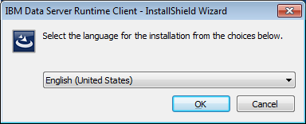

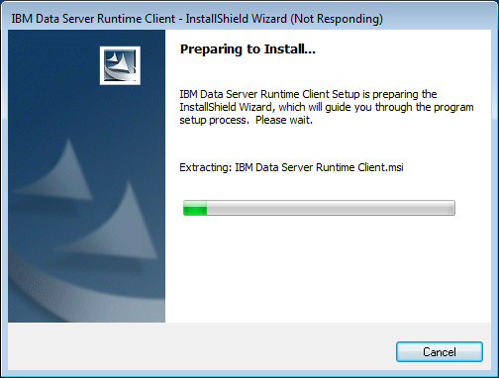

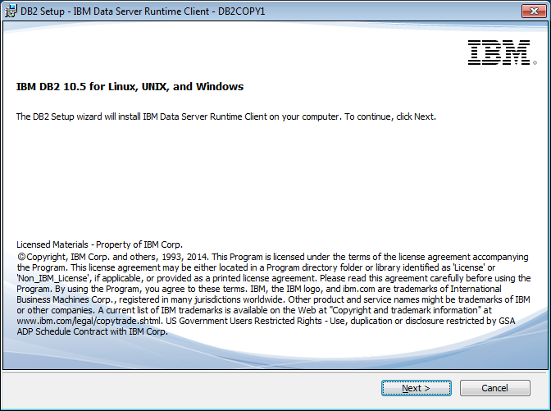

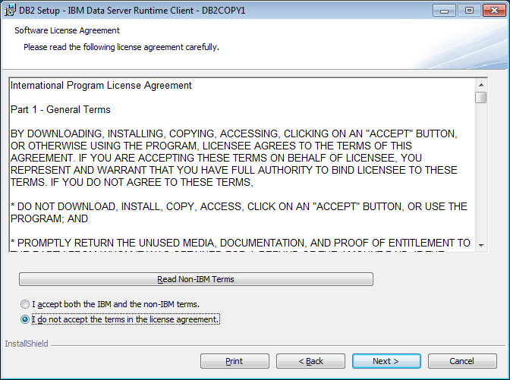
Accept the license agreement and click on Next:
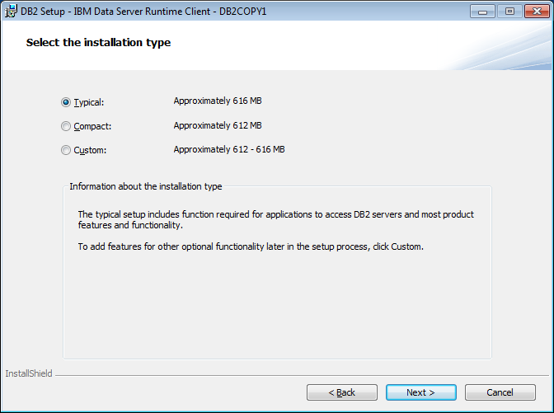

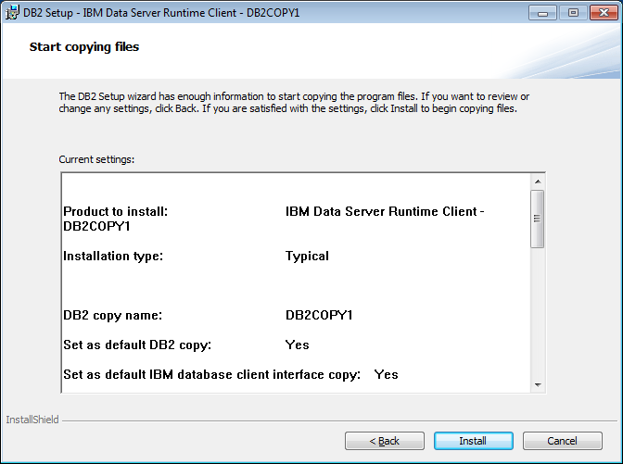

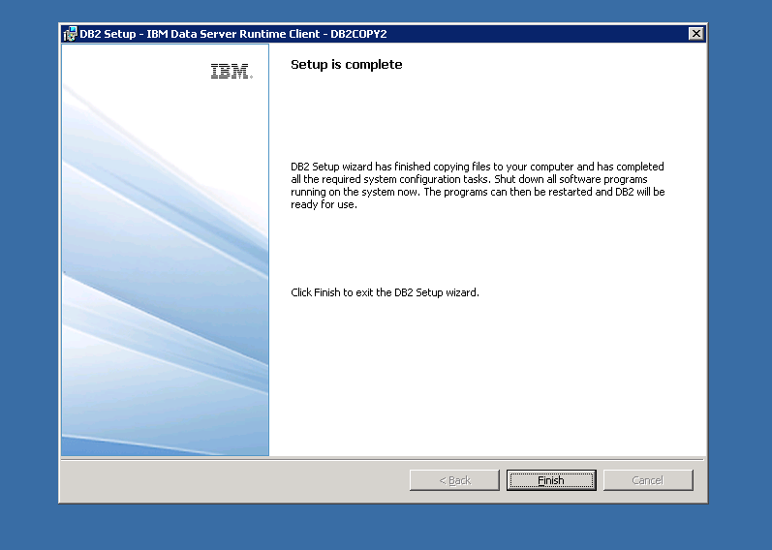

Search for ODBC on the search in windows start, select the type of drivers needs to be configured
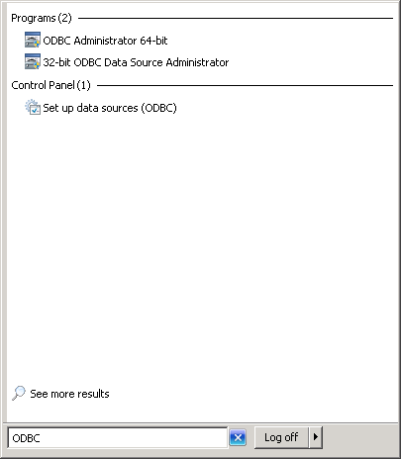
Select 64 bit if you want to configure 64 bit or DSN.32 for 32bit DSN
Click on the type of DSN to be configured and run as an administrator. Our version of BRIO is a 32-bit application.
The below screen is the default screen which shows up when you click on ODBC. Ignore anything under User Data Source . The screen what you looking might be different from what is in the document. But you should be able to see ‘System DSN’ on the top of the screenshot
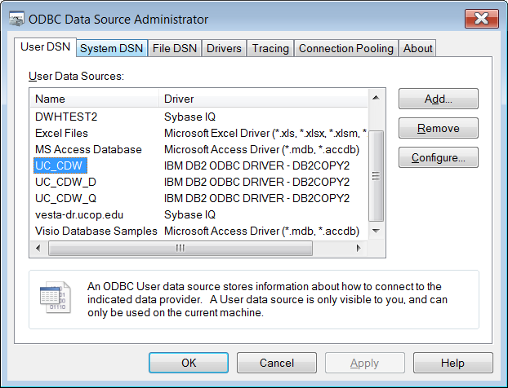
Click on System DSN. You may not see any System Data Sources yet, or you may
have different ones from what is shown here:
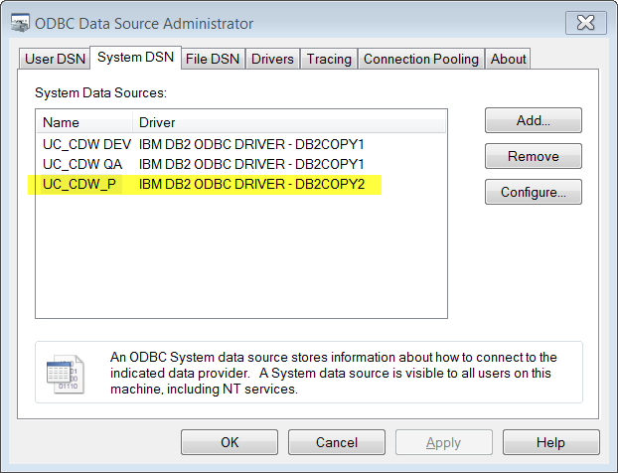

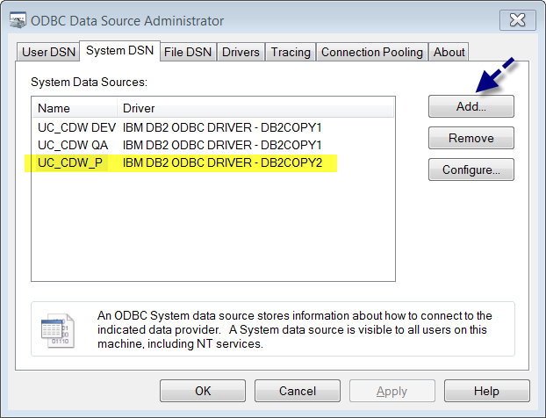

Click on Add
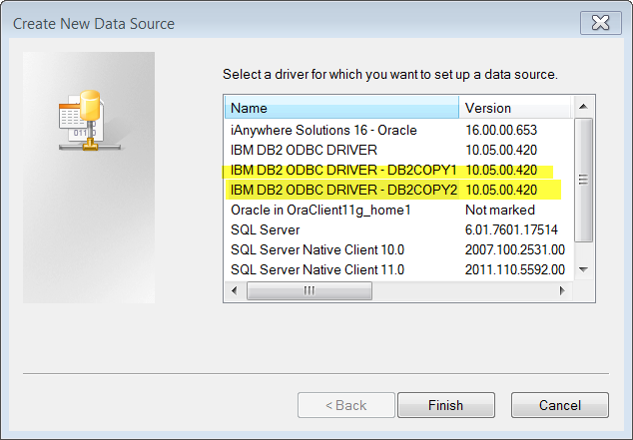
Select IBM DB2 ODBC Drivers DB2COPY1 or DB2COPY2, depending on which has been configured on your PC.
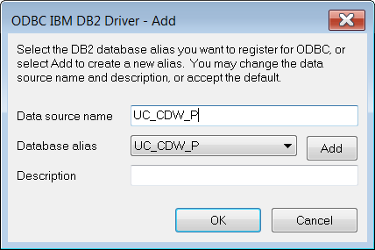

UC_CDW_P is the production data source. Click Add.
You can provide the user ID but do not enter the password. The UC_CDW password will change
whenever you change your AD password and you will not be able to edit this setting yourself because it
requires administrative privileges.
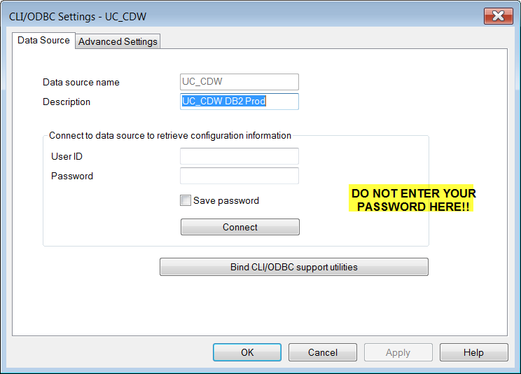

Click on TCP/IP
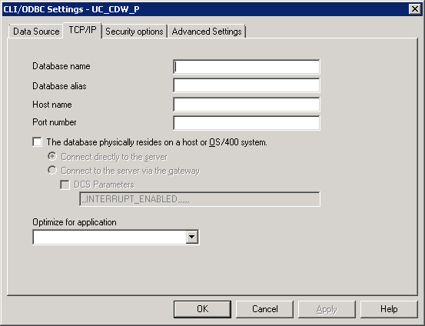
Provide the database name, database alias, host name and port. For Production host name is dwp1.ucop.edu
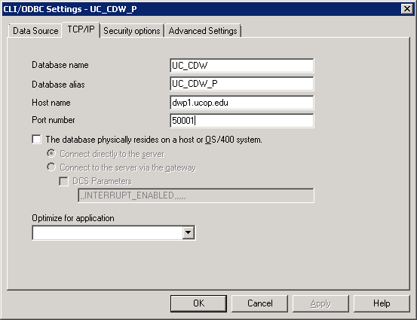
Click on Security options
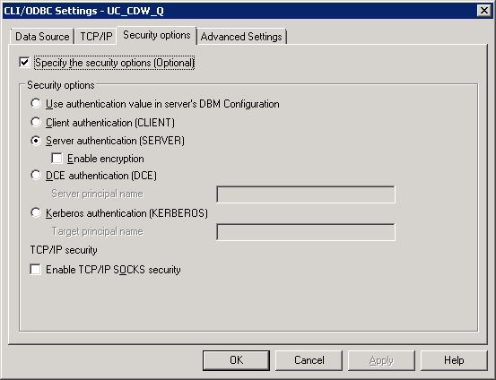
Click OK
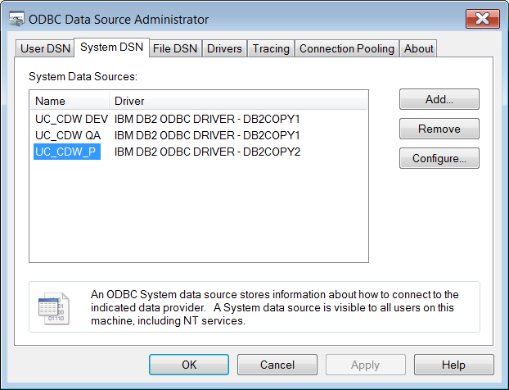

Done. Go test it out.

